Week beginning 1st June 2020
Focus French: Greetings
Below are some greetings in French and English and how to say the word in French.
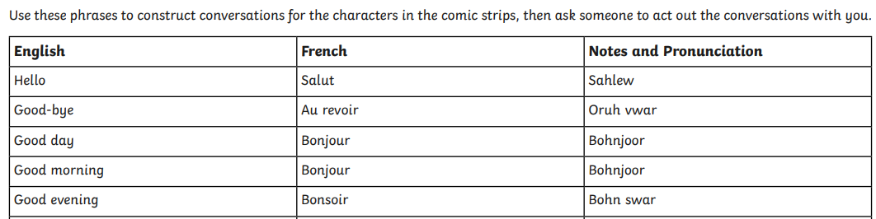
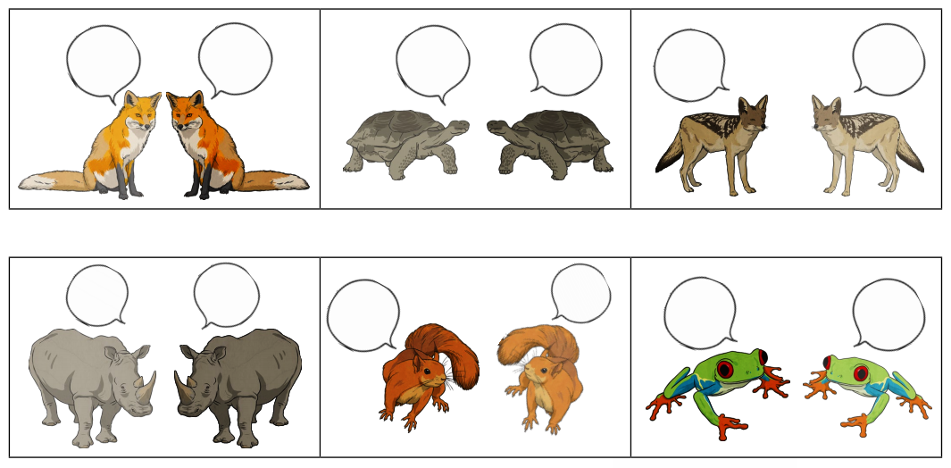
Can you draw comic strip pictures of your own choice and add the French greetings into the speech bubbles. (Or use the pictures below).

