Science Home Learning Week beginning 15th June 2020
Focus: Living Things and their Habitats
Classification
Complete the KWL sheet which is attached. You can write the questions and answers onto paper to avoid printing the sheet out.

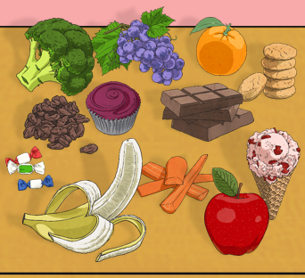
Then……look at the picture of food and decide how you would sort and classify them. Once you have sorted them into TWO groups, can you sort each group into two smaller groups again? You could sort them into healthy and unhealthy; then fruit and veg; then roots and florets etc. Draw or write your groups you have created.

