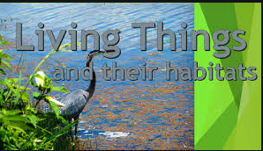
Can you name some helpful micro-organisms?
Can you explain what these key words mean?
Micro-organism-
Species-
Arachnids-
Molluscs-
Crustaceans-

Living things and their Habitats
List as many different species of one animal or plant that you can think of?
What would you like to find out about Living Things and their Habitats? Think scientifically!
How would you classify these living things?
Roses -
Ant -
Snake -
Worm -
Snail -
Spider -
Whale -

What are the characteristics of this animal?
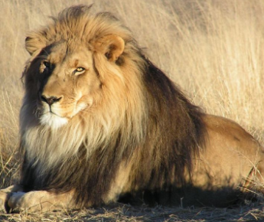

Who was Carl Linnaeus? What was he famous for?


