FSU Home Learning-11.05.20
Our key priorities for learning this week:
- Maths- F1- To recognise and order numbers to 5/10.
F2- To subtract by counting back/ using a number line.
- English- F1 – To draw and talk about how a frog grows and changes over time.
F2 – To draw and write simple sentences about how a frog grows.
- Reading- F1- To show awareness of rhyme and begin to identify rhyming pairs.
F2- To write simple words with the trigraph ‘air.’

  English-please complete every day  Writing & Reading:  F1 & F2  Read /watch different stories and information texts about the lifecycle of a frog. See links below for some ideas-  https://www.youtube.com/watch?v=dJTNcE1qO6g  https://www.youtube.com/watch?v=F3ElGMVU6SY  https://www.youtube.com/watch?v=AMs3waaW75g (might like to start from 0.43 as there is some footage of a frog eating another frog before!!)  https://www.youtube.com/watch?v=EqUwVvcz0Ck  https://www.youtube.com/watch?v=mhrlPr6Yk7Q  Discuss how a frog grows and changes over time. Can you name the 4 main stages of development?  F1: Draw a picture and talk to your grown up about each stage of the frog’s development.  F2: Draw a picture and label or write a simple sentence about each stage of the frog’s development.  Phonics:  F1: Read/watch ‘Oi Frog’ by Kes Gray to help with your phonics activities this week.  https://www.youtube.com/watch?v=oPDyXsSbxOY  Can you listen and identify the rhyming words in the story? (see website for extra rhyming activities.)  F2: This week’s sound is made by the trigraph ‘air’. Hunt for the Trigraph in books/texts around you! Can your children write these words as you say them? Fair, hair, chair, pair, stair, lair, dairy, fairy repair. Can they put one, two or even more into a sentence and write it?  There is also an extra ‘air’ activity on the website if you would like to have a go.  https://www.youtube.com/watch?v=uZHKK9jnfFQ  https://www.bbc.co.uk/bitesize/topics/zvq9bdm/articles/zj39382  Check out the free phonics games on this site- https://www.phonicsbloom.com/uk/game/list/phonics-games-phase-3 | 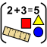  Maths-please complete everyday  F1: Use your digit cards to read and recognise numbers. Can you put the numbers in order to 5/10? Or can you and your grown up make a big number line on a roll of paper or using chalks in your garden? Now using a small toy or yourself play different games with the numbers. Maybe you can pretend to be a frog and jump along your number line. Your grown up could ask you or your toy to  *stand on number…..  *find a number that is more/less than ….  * find your age/ numbers on your door etc  Get you grown up to hide a number or muddle 2 numbers up. Can you identify the missing number or put the numbers back in the right order?  Have fun!  Also have a go at this frog number game on twinkl-  https://www.twinkl.co.uk/go/resource/tg-ga-31-too-many-frogs-counting-up-to-10-game  F2: This week we would like you to focus on counting back to help solve subtraction calculations. Have a go at creating a large number line (chalked outside, on an old roll of wallpaper, made out of string or wool etc) to hop like a frog backwards on to solve some subtraction calculations. 6 – 4 =, 7 – 3 =, 5 – 2 =, 9 – 6 = . Can you create some of your own?  Maybe you could try some two digit numbers up to 20 too?!  *Remember to stand on the first number in the calculation and only jump back one number at a time. You could record your calculations in your workbook.  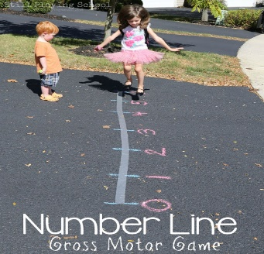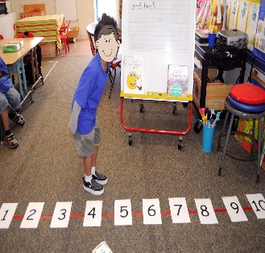
Choose at least one activity per day from the list below

  UW:W Understanding the World: People and Communities  F1 & F2 :  This half term in school we would have been thinking about our special stories and stories that are special to Christian people. Do you know the name of the book that is special to Christian people?  Some of your teachers have been sharing their special stories on you tube with you. Talk to your grown up about stories that are special to you and why you like them. |  |   EAD:EMM Expressive Arts and Design: Exploring and using media and materials  F1 & F2  Keep going with the Charanga online music sessions!  Here is a fun song about a little green frog. Can you sing the song and do all the different actions-  https://www.youtube.com/watch?v=QjYkG8jDsJU  Number songs and rhymes- Do you know any number songs and rhymes? Can you sing them together? Here is one song to get you started-  https://www.youtube.com/watch?v=WSC-gHBU_d0  See the attached ‘Five Little Tadpoles’ rhyme to have a go at learning and performing with your family.    Make a frog using different craft materials you may have at home (see website for crafty frog ideas). Get creative and have fun! Please send photos of your finished frog to your class teacher.

PD: MH Physical Development: Moving & Handling
F1 & F2:
Now is your time to get creative and dance like a frog! (see website for idea sheet)
This week we would like you to practise your jumping skills. (see website for idea sheet)
Fine motor skills-
F1: Practise copying different patterns. Use different writing tools to create your patterns. Or sprinkle some flour, glitter or cornflour in a tray and use your finger to make the patterns. (see website for pattern cards.)
F2: We would like you to practise your number formation this week. See the attached sheet to guide you. You could do this in your workbook or in flour, paint, shaving foam, cornflour, talc glitter etc if you prefer!

