Week beginning 1st June 2020

Focus: RE – Hindusim
The story of Rama and Sita

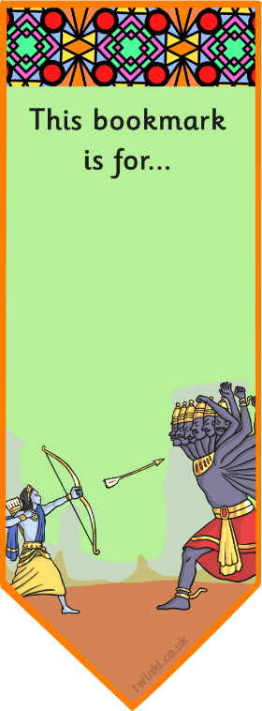
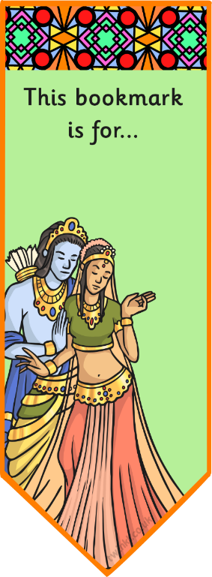
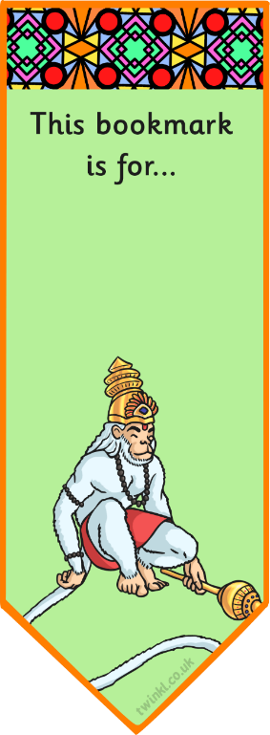
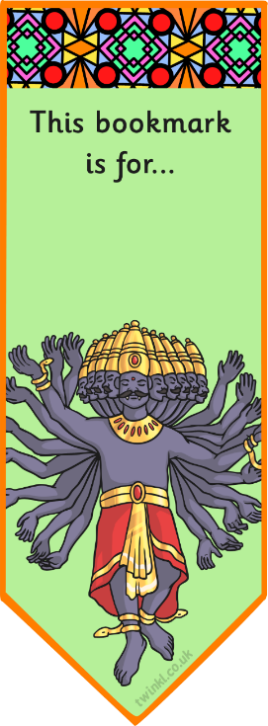
Look at the story of Rama and Sita then design and draw a bookmark that shows part of the story or any of the characters.
Below are some examples.

