
HOME LEARNING

Reading – If you have any queries about your child's reading, please use the Reading Records to pass on any comments to the teacher. Children should aim to read at home for 15-20mins daily. This may be reading to an adult or independent reading. Please record reading in the green reading record and ensure it is in school every day along with their reading book.
Spellings – This week in our spelling lessons, we have been looking at revisiting words from year 2 and 3. Please have a look at the words at home, we have attached the words in this newsletter.
Maths – For home learning this week, please log in and have a go at TT rockstars. We are starting this year by revisiting the 2s, 5s and 10s!
Times tables – Times tables are key to so many areas of maths so we would like children to try to spend a little bit of time practising regularly - every day if possible! Children can log on at https://play.ttrockstars.com and https://www.topmarks.co.uk/maths-games/hit-the-button.
They all have their TT Rockstar log ins and these do not change throughout their time at our school. It is a good idea to memorise the log in!

YEAR 3_4 Weekly Rockathon – This challenge will take place each week where the children will compete against each other. 1 correct answer = 1 correct point. Each week there will be a prize for the 2 top Year 4 students and the 2 top Year 3 students.

Also, we've included a times tables mat. You could refresh and start learning the key statutory words for year 3 and 4.

NOTICES:
Please note our usual PE Days:
34P: Wednesday Dance, Thursday Athletics
34J: Monday Dance, Wednesday Athletics
34K: Tuesday Athletics, Friday Dance
- Please note that children need to remove their earrings for PE, therefore, it might be easier for them to be removed on PE days. Thank you for your cooperation. Keep your PE kit in school, thank you.
- We like our snacks! Please bring in a healthy mid-morning snack if you like for break time.
Dear All,

It has been such a pleasure to be back in school, and all the new 3&4 classes are settling very well into their new class bases and routines. Here are the highlights of the first full week back:
- Scientific work on nutrition
- Typography art examples
- Teamwork games in PE
- Place value in maths with extending numbers beyond 1000 and representing numbers to 10 000
- Writing Assessment and generating our own animal characters to describe
- Reading and new AR books so we can start quizzing soon!

Wishing everyone a very restful and happy weekend! See you all on Monday!

The Year 34 Team

Year 3/4 News
Friday 11th September 2026
SUBJECT SPECIFIC VOCABULARY
Each week we will share vocabulary linked to the learning we have planned for the coming week. It is helpful for the children to become familiar with some of these words before they meet them in their lessons. There is no need to produce any work linked to these words, a conversation at home about the words would be brilliant!
Maths: represent, thousands, partition
Science: food groups, skeleton, vertebrate
Art: typography, font, precision

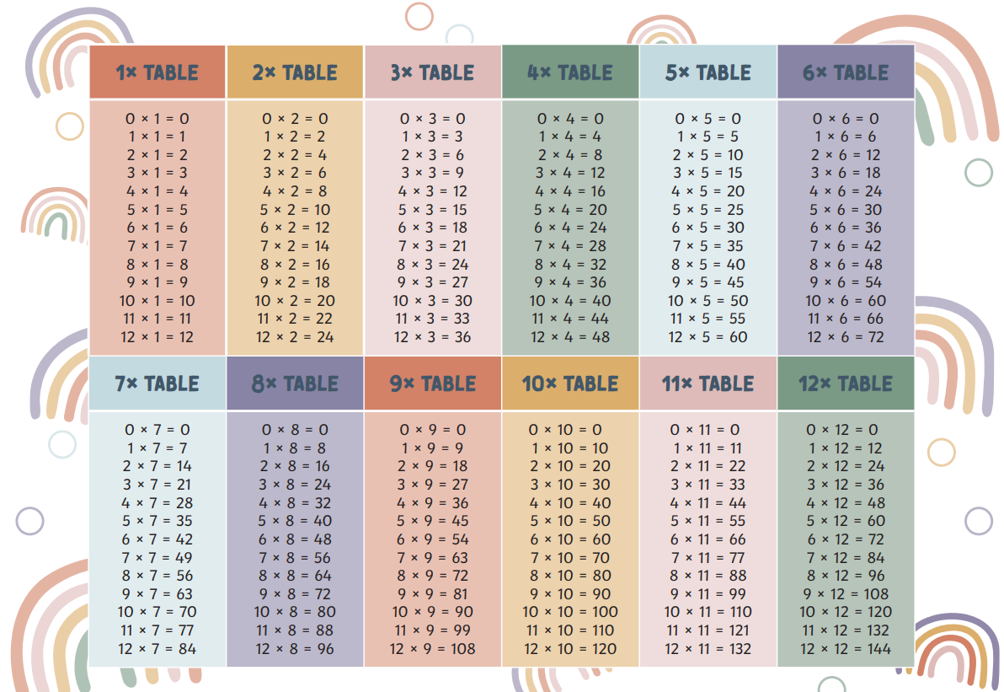
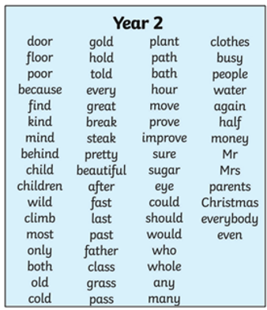
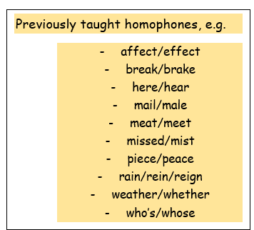
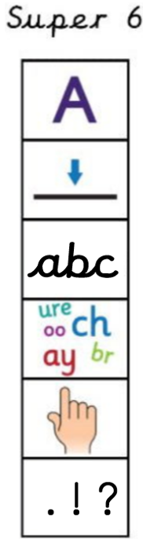
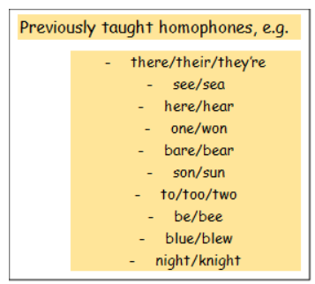
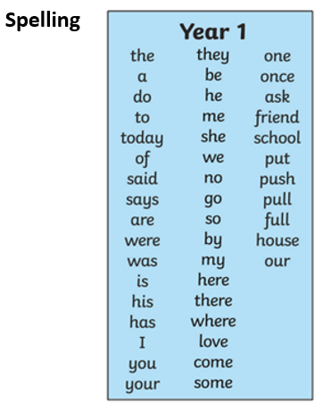
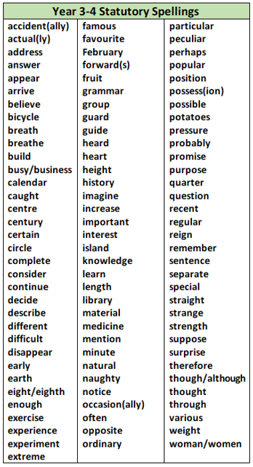
Year 4
Year 3

