
Home Learning Expectations
Reading – 15/20 mins daily
Magma – No more than 30 mins unless you’re happy to continue.
Spelling Shed – Complete assignment set
TT Rockstars – 5/10 mins a day

NOTICES:
Please be reminded that some children in Y3 will have Bikeability next week. Please refer to your message from the office for details.
Please note that children need to remove their earrings for PE, therefore, it might be easier for them to be removed on PE days. Thank you for your cooperation. Keep your PE kit in school, thank you.
- Please ensure Reading Records are in school everyday.
- We like our snacks! Please bring in a healthy mid-morning snack if you like for break time.
HOME LEARNING

Reading – If you have any queries about your child's reading, please use the Reading Records to pass on any comments to the teacher. Children should aim to read at home for 15-20mins daily. This may be reading to an adult or independent reading. Please record reading in the green reading record and ensure it is in school every day along with their reading book.
Spellings – This week in our spelling lessons, we have been looking at spelling words where ‘y’ makes an /i/ sound. Please log into Spelling Shed to complete the activities for these words: symbol, gym, myth, synonym, Egypt, lyrics, pyramid, system, mystery, gymnastics. For additional practice, every week, we will post 5 spellings from the 3/4 Statutory Spellings list (attached overleaf). Therefore, please also complete the ‘3/4 Statutory Spellings Week 3' for these words: appear, fruit, guide, notice, probably. (www.edshed.com)
Maths – This week, the children have been learning about rounding. Please log in to Magma Maths to complete the labelled assignment. (magmamaths.com) - Magma Maths - The maths platform to advance pupil learning
Times tables – Times tables are key to so many areas of maths so we would like children to try to spend a little bit of time practising regularly - every day if possible! Children can log on at https://play.ttrockstars.com and https://www.topmarks.co.uk/maths-games/hit-the-button.
They all have their TT Rockstar log ins and these do not change throughout their time at our school. It is a good idea to memorise the log in!
YEAR 3_4 Weekly Rockathon – This challenge will take place each week where the children will compete against each other. 1 correct answer = 1 correct point. Each week there will be a prize for the 2 top Year 4 students and the 2 top Year 3 students. There will also be 2 special recognition prizes too!

Optional Extras – Sometimes children are keen to do something extra linked to their learning. We will give ideas but there is no requirement to complete these tasks.
Geography – See how many capital cities in Europe you can find on a map and any facts about them!

Dear All,

We have had an amazing week in Year 3/4 this week! We are continually seeing ample amounts of our learning behaviours of: Casper Cat, Tommy Tortoise, Olivia Owl and Beatrice Bee across all classes! Here are some the highlights of the week:

- Geography – Delving into atlases
- English – starting our new unit ‘Mini Rabbit is Not Lost’
- Rounding to the nearest 10, 100 and 1000 in maths
- Dance – choreographing synchronised movements keeping to the beat.

Wishing everyone a very restful and happy weekend! See you all on Monday!

The Year 3/4 Team

Year 3/4 News
Friday 2nd October 2026
SUBJECT SPECIFIC VOCABULARY
Each week we will share vocabulary linked to the learning we have planned for the coming week. It is helpful for the children to become familiar with some of these words before they meet them in their lessons. There is no need to produce any work linked to these words, a conversation at home about the words would be brilliant!
Reading: dismal, ghastly, despicable, squalid
Maths: roman numerals, represents, value, left, right
Science: endoskeleton, exoskeleton, hydrostatic skeleton

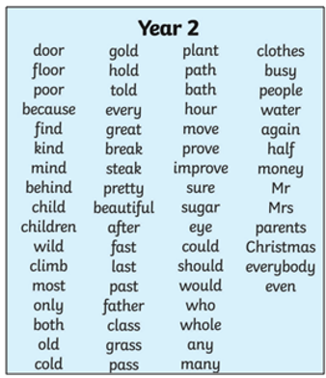
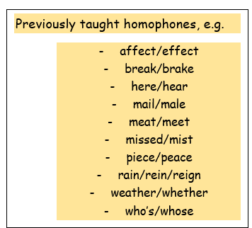
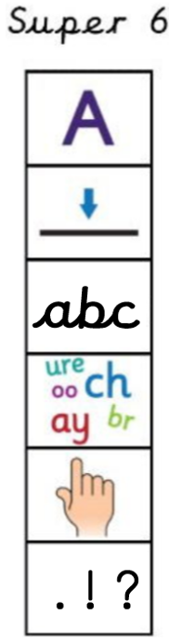
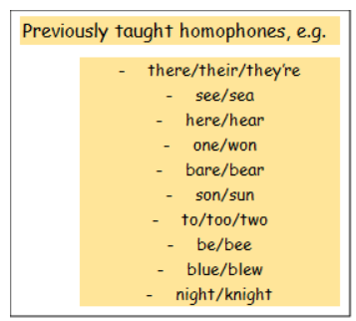
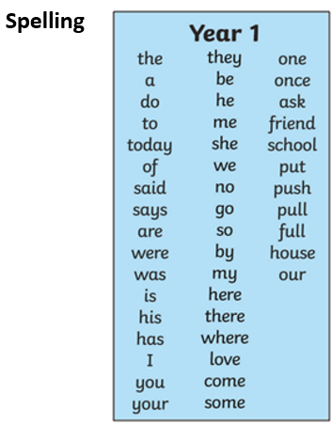
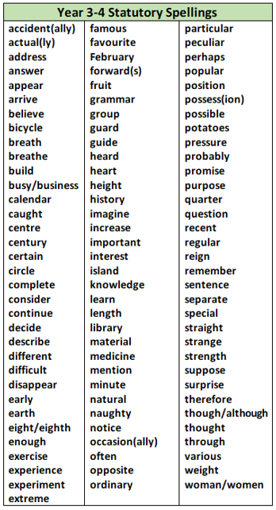
Year 4
Year 3

