NOTICES:
- Please note that children need to remove their earrings for PE, therefore, it might be easier for them to be removed on PE days. Thank you for your cooperation. Keep your PE kit in school, thank you.
- We like our snacks! Please bring in a healthy mid-morning snack if you like for break time.
- Please bring books and Reading Records in every day.
HOME LEARNING

Reading – If you have any queries about your child's reading, please use the Reading Records to pass on any comments to the teacher. Children should aim to read at home for 15-20mins daily. This may be reading to an adult or independent reading. Please record reading in the green reading record and ensure it is in school every day along with their reading book.
Spellings – This week in our spelling lessons, we have been looking at spelling words spell words with the prefix ‘in-’ meaning ‘not’. Please log into Spelling Shed to complete the activities for these words: inability, inactive, inadequate, incorrect, incurable, indefinite, inelegant, inflexible, insecure, invisible. For additional practice, every week, we will post 5 spellings from the 3/4 Statutory Spellings list (attached below). Therefore, please also complete the ‘3/4 Statutory Spellings Week 5' for these words: length, often, heart, medicine, question.
Maths – This week, the children have been learning about column addition. Please log in to Magma Maths to complete the assignment labelled (magmamaths.com) - Magma Maths - The maths platform to advance pupil learning
Times tables – Times tables are key to so many areas of maths so we would like children to try to spend a little bit of time practising regularly - every day if possible! Children can log on at https://play.ttrockstars.com and https://www.topmarks.co.uk/maths-games/hit-the-button.
They all have their TT Rockstar log ins and these do not change throughout their time at our school. It is a good idea to memorise the log in!

YEAR 3_4 Weekly Rockathon – This challenge will take place each week where the children will compete against each other. 1 correct answer = 1 correct point. Each week there will be a prize for the 2 top Year 4 students and the 2 top Year 3 students. There will also be 2 special recognition prizes too!

Optional Extras – Sometimes children are keen to do something extra linked to their learning. We will give ideas but there is no requirement to complete these tasks.

At the back of sheet, there are some mind-teasing maths problems for you to have a go at if you like!

SUBJECT SPECIFIC VOCABULARY
Each week we will share vocabulary linked to the learning we have planned for the coming week. It is helpful for the children to become familiar with some of these words before they meet them in their lessons. There is no need to produce any work linked to these words, a conversation at home about the words would be brilliant!
Science – muscle, contract, relax, tendon
Maths – addition, subtract, exchanging, equals

Dear All,

The children have had a brilliant week. Here are some the highlights of the week:

- Writing their final stories about the animal characters.
- Finding out about muscles in science!
- Started using column addition and subtraction in maths
- Developing our coding skills to move a sprite in computing.
- Continuing to learn about the Creation Story in RE.

Wishing everyone a very restful and happy weekend! See you all on Monday!

The Year 3/4 Team

Year 3/4 News
Friday 16th October 2026

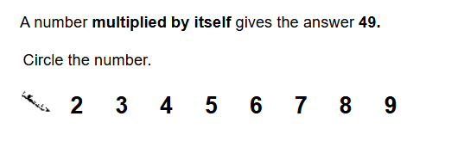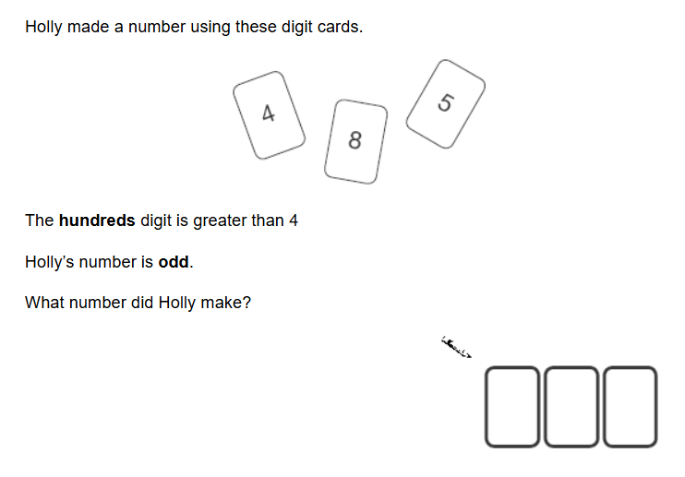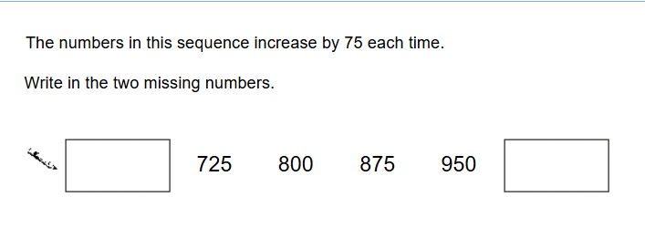
Reasoning

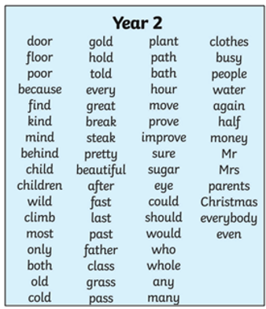
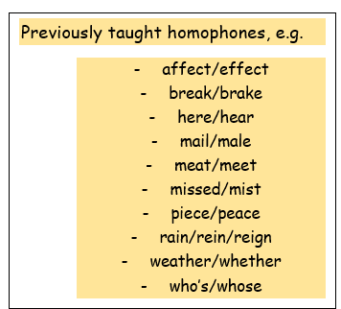
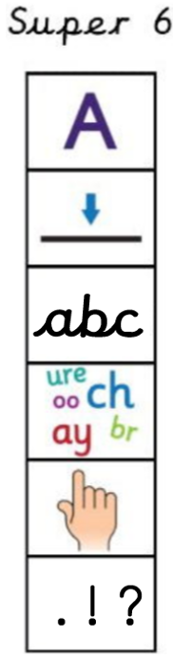
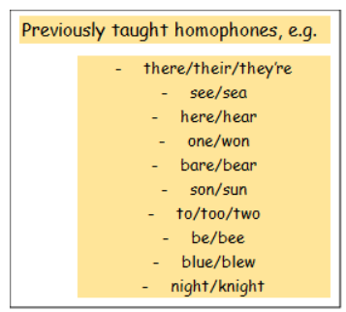
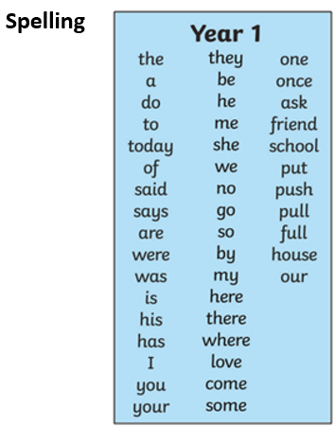
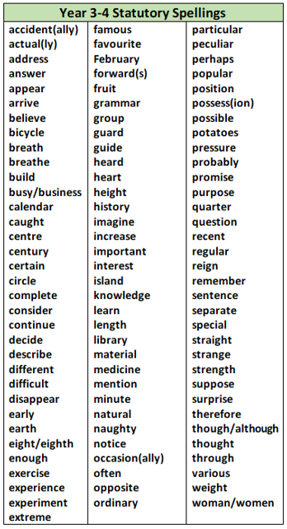
Year 4
Year 3

