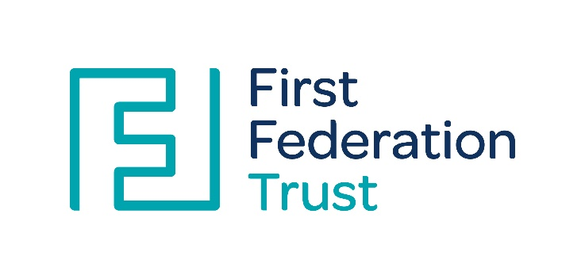
First Federation Trust
Principles and purposes of feedback in the classroom
Our guidelines are underpinned by the evidence of best practice from the Education Endowment Foundation and other expert organisations. The Education Endowment Foundation research identified that when done well, effective feedback supports pupil progress, builds learning, addresses misunderstandings and thereby closes the gap between where a pupil is and where the teacher wants them to be. The main role of feedback, at least in schools, is to improve the learner, not the work. The idea is that, after feedback, pupils will be able to do better at some point in the future on tasks they have not yet attempted.
These principles provide some guidelines for our schools. Each school will consider these within their own context, in order to meet the needs of their children across the school, and make amendments to practice, where appropriate.
Feedback is likely to be more effective if it is approached systemically, and specifically, by adopting three fundamental principles:
- Foundations of high quality instruction in place before the feedback is given
- providing well-timed information that focuses on improvement
- taking into account how learners receive and use that information.
These principles are explained in more detail below.

Lay the foundations for effective feedback:
The first task of the teacher, before feedback is delivered, is to provide high quality instruction, including the use of two formative assessment strategies. Good initial instruction will reduce the work that feedback needs to do while formative assessment strategies are required to:
- Set learning intentions (which feedback will aim towards);
- Assess learning gaps (which feedback will address).
In conjunction with the FFT 4 pillars of effective teaching and learning, teachers deliver effective teaching by:
  - building on pupils’ prior knowledge and experience;
  - avoiding overloading pupils’ working memory by breaking down complex material into smaller steps;
  - encouraging the retention of learning by using repetition, practice, and retrieval of critical knowledge and skills;
  - delivering a carefully-sequenced curriculum which teaches essential concepts, knowledge, skills, and principles;
  - using powerful analogies, illustrations, examples, explanations, comparisons, and demonstrations;
  - being aware of common misconceptions and prepare strategies to counter them;
  - planning effective lessons, making good use of modelling, explanations, and scaffolds to support learning;
  - adapting teaching in a responsive way to support struggling and excelling learners while maintaining high expectations for all
  - providing pupils with tools and strategies to plan, monitor, and evaluate their learning.
The reason that effective feedback requires careful preparation is because the quality of feedback that a teacher can provide depends crucially on the quality of the evidence about learners’ achievement that is available. If a teacher cannot think of what to say to a pupil—having seen the pupil’s work—then the fault is most likely that the questions, task, or activities that were assigned were not designed with a view to giving feedback in the first place.
Teachers should provide teaching that is adaptive to pupils’ needs and using evidence about learning to adjust instruction to ensure that learning moves forward. In terms of what this looks like in the classroom, this may be summarised in five strategies as seen in Figure 1 below (this should be read in conjunction with the FFT principles of assessment).
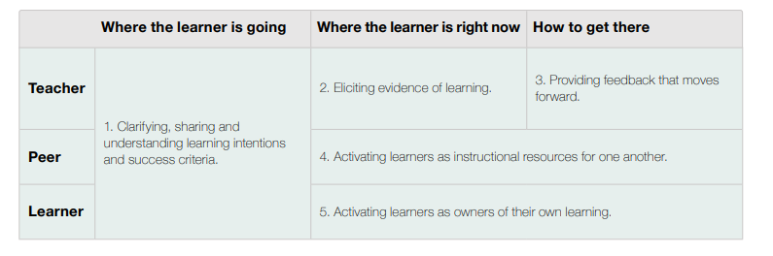
Fig 1: The five key strategies of formative assessment (Wiliam, 2018)

To maximise the impact of feedback and marking it must be embedded in effective assessment for learning:
- Children and all adults in the classroom must be clear about the learning taking place and the expected outcomes (e.g clear, focused learning objectives; success criteria which support these; appropriately pitched learning activities)
- Skilful questioning is used to explore children’s understanding of the learning taking place; identify misconceptions; challenge and develop thinking, learning and understanding leading to opportunities for adults to give well directed feedback.
- When and where appropriate, during the lesson, feedback given to groups/ individuals and the whole class can address misconceptions; provide opportunities for extra challenge; allow children to reflect on their learning and make improvements during the lesson.
- Effective self and peer assessment allows children to reflect on progress in their learning and identify areas for success and opportunities for improvement.

Once effective initial instruction has been delivered— and following the establishment of the learning intention and formative assessment of pupils’ understanding— teachers should then provide appropriately timed feedback, which focuses specifically on the task, subject, and/or pupils’ self-regulation strategies.

Deliver appropriately timed feedback that focuses on moving learning forward:
The evidence regarding the timing and frequency of effective feedback is inconclusive. On the one hand, immediate feedback may be effective as it could prevent misconceptions from forming early on. However, delayed feedback could also be beneficial as it may force pupils to fully engage with the work before being given an answer. This may lead to them working hard to retrieve information they’ve already learned, which could help pupils to remember more of the learning. Decisions around the timing of feedback are left to teachers as their judgement plays a crucial role in delivering feedback at the appropriate moment. To guide this judgement, teachers should consider three things: the task, the pupil, and the class. (See Appendix A for examples of each and Appendix B for information regarding whole class feedback).
Feedback should focus on moving learning forward, targeting the specific learning gap identified by the teacher, and ensuring that a pupil improves. Specifically, high quality feedback can focus on:
- the task (its outcome and advice on how to improve when doing that specific type of task),
- the subject (and the underlying processes within that subject),
- and self-regulation strategies (how pupils plan, monitor, and evaluate their work).

Feedback that focuses on a pupil’s personal characteristics is less likely to be effective. This may be because feedback about a person may not provide enough information to close a learning gap and move learning forward. It could also distract the learner away from learning, becoming self-conscious and focusing instead on the impact the feedback has had on their self-esteem.
Written feedback
If we follow the principles for feedback, sometimes lots of children would benefit from a next step comment; at other times, no one will. As a Trust, we encourage our staff to use their professional judgement to decide when is the right time to provide written feedback, to undertake a ‘surface mark’, or when a next step is the right approach. It goes without saying that this judgement needs to be based on what will most positively impact a child’s progress.
In addition, schools will have a specific reward system that they will use to acknowledge a child’s success. This could be House points/ stickers etc (in line with the school’s behaviour policy). These will be used to indicate where a child has worked hard or shown great progress within a piece of learning.
Plan for how pupils will receive feedback:
A variety of pupil-level factors, such as pupil motivation, self-confidence, trust in the teacher, and capacity to manage information, are all likely to impact the effectiveness of the feedback provided. Careful planning is required to provide time and opportunities for pupils to use the feedback given.
The following strategies will support in developing children’s willingness to receive and act on feedback:
- Discussing the purpose of feedback. Conducting discussions with the class, or with particular individuals, on why feedback is being given may support pupil motivation and desire to receive feedback. The key is to emphasise that feedback is provided not to be critical but because the teacher has high standards and fully believes pupils can meet them.
- Modelling the use of feedback. Pupils may be more likely to welcome and use feedback if this is modelled to them by their peers. If a peer expresses a willingness to receive feedback and recognises that feedback is not designed to be critical of them but offered to improve their learning, a pupil is more likely to use feedback to improve their own learning. Teachers may, therefore, look to explore ways of modelling the effective use of feedback. For example, could whole-class discussions focus on a learner who has improved their work because of feedback? Additionally, could the effective use of feedback be celebrated when it happens in the classroom?
- Providing clear, concise, and focused feedback- which features task, subject and/or self-regulation advice. Sometimes less is more.
- Ensuring pupils understand the feedback given. Careful thought should be given to the language and content used in feedback to ensure that pupils understand what the teacher is saying. If providing written feedback, teacher handwriting also needs to be clear enough for pupils to comprehend and written in an age appropriate way that a child can engage with.
Whichever strategy a teacher opts to use, they should monitor whether their feedback is being used by pupils. If not, the approach will need to be adapted to ensure that pupils are welcoming and acting on the information provided.

As Dylan Wiliam has explained, effective feedback needs to be used as a windscreen, rather than a rear-view mirror. In other words, it should be a ‘recipe for future action’. It is crucial that pupils are given the time and opportunity to use the feedback given so that it moves learning forward. Rather than just commenting on work that has been finished, it needs to impact the future work that a pupil will undertake.
Self-assessment and peer evaluation
Pupils will be given opportunities to reflect on their own learning in order to identify progress towards success criteria/ targets and identify areas for improvement. For self and peer evaluation to be successful, effective feedback and marking must be modelled by the teacher; children must be taught how to assess and evaluate their own learning/ work.
Pupils should also be given the opportunity to work with other pupils to assess and evaluate others’ learning and to make suggestions for improvement. (See Appendix C for suggestions about how to use self and peer evaluation)

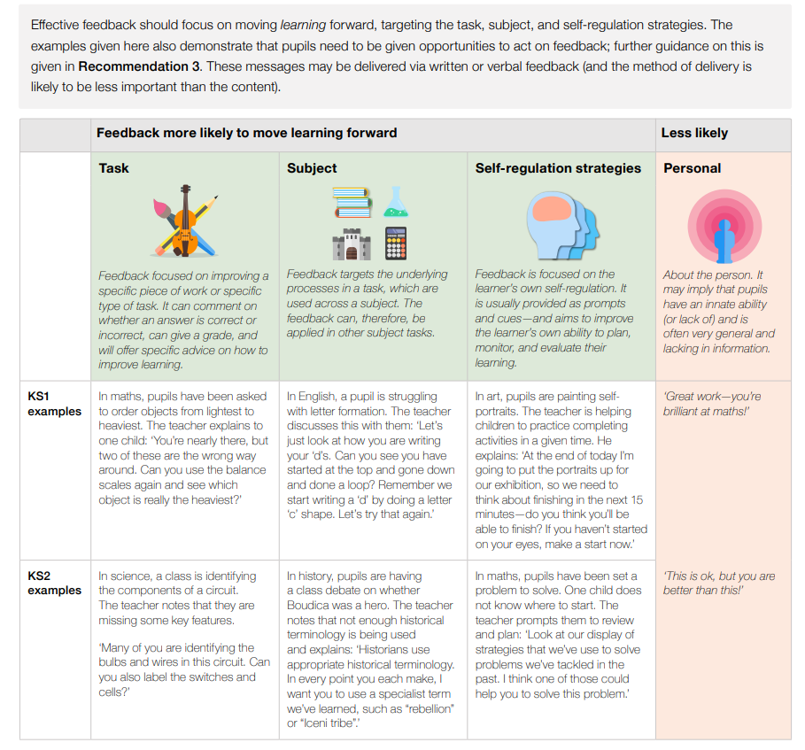
Appendix A:
Appendix B:
Whole class feedback
One method to reduce the amount of time spent marking pupils’ books is to use whole class feedback. This involves using a single sheet and providing comments on the class's work as a group, rather than for individual pupils. Teachers can use the feedback sheet as a point of discussion for the next lesson with the whole class, focussing on strengths, areas to develop and highlighting effective examples from within the class.
Whilst looking at books at the end of the lesson, teachers will make notes on the key messages to feedback to children at the start of the next lesson using the proforma (See table below). This is a suggested template/model but can be adapted to suit the individual school needs. This will be completed at the discretion of the teacher or as agreed within the school.
This can feed into the next lesson and can be a useful tool to address misconceptions and model techniques such as editing and improving work. Modelling may occur at any stage of the lesson to address deep rooted misconceptions, clear up confusion or provide further scaffolding.

What might whole class feedback look like in a literacy lesson:
- With writing, we suggest a redrafting approach. When the teacher looks at the books after a lesson, they make notes on one piece of paper for the whole class about what went well and what still needs work.
- This might include things to do with the technical accuracy of the writing; spelling errors, punctuation omissions, and other transcription mishaps, as well as any content improvements.
- Where individual children have done particularly well or poorly, the teacher will make a note and use these in the lesson as a teaching point (where it is an error, she might use the mistake anonymously or write a similar sentence with the same error).
- In the next lesson the teacher will share extracts from pupils’ work, using either the visualiser or just a few typed lines to show examples of good work.
- For mistakes, the teacher might share an example which an anonymous or fictional piece where the child has confused describing a character with listing their clothing, piling up adjective after adjective.
- The children would then suggest how this might be improved. They might spend time with a partner – we always use mixed ability pairs for this – seeing if they included good description in their writing. Together the pupils reflect if the text would be improved by adding any additional description.
- Finally, in pairs they read each other’s work together and suggest improvements, alterations and refinements which the author of the piece then adds – in green pen.
The whole point of this approach is that the next step is the next lesson. You don’t need to write down the next step for each pupil either; you can either give them the opportunity to put it into action or teach them whatever the next step is for them.
Date of lesson: |  |  | Year:
Learning objectives:
What did pupils do well? |  | Basic skills errors |  |  | Presentation
e.g Use of paragraphs or adjectives |  | e.g SPAG: Piece> peace/ Capital letters for names |  |  | e.g Cross out mistakes with one line –don’t scribble
Work to praise and share |  | Need further support |  |  | Feedback and improvement time
e.g J. Bloggs work- use of adjectives |  |  |  |  | - Sam Smith with TA to write next two paragraphs  - Emily Johnson with TA to practice use of full stops
Next steps for learning
- Continue with next three paragraphs of story
- Understand beginning, middle and end of stories

Appendix C:
Self & Peer Evaluation Prompts
These prompts could be modelled, taught and may be displayed in the classroom or on table cards until the children are confident in using them:

- I liked ……
- I learned…
- I think I will…
- I never knew…
- I discovered…
- I was surprised…
- I still wonder…
- I have learnt….
- Next time I could.....
- I now know.....
- I found....... difficult because......
- I solved....... by......
- The best example of …… is …….
- I like the way you......
- ....... is effective because........
- You could make your work better by …………
- Have you thought about......
- If we look at the success criteria we can see.......
- Next time you could......

Peer Marking
  - Partners should be similar ability
  - Agree rules: respect, listen…
  - Explain & model the process with the whole class
  - Compare & contrast two pieces of work
  - Author reads to editor
  - Begin with a positive comment
  - Comment against 1 or 2 specific Success Criteria
  - Author adds notes and changes work
  - Process could take place during the extended writing process

Peer Marking Agreement
Our agreement on marking partnerships – We decided that there were some rules we all needed to keep.
When we become marking partners we all agree to:
  - Respect our partner’s work because they have done their best and so their work should be valued
  - Try to see how they have tackled the learning objective and only try to improve things that are to do with the learning objective
  - Tell our partner the good things we see in their work.
  - Listen to our partner’s advice because we are trying to help each other do better in our work
  - Look for a way to help our partner achieve the learning objective better by giving them an improvement suggestion
  - Try to make our suggestions positive and as clear as possible.
  - Get our partner to talk about what they tried to achieve in their work.
  - Be fair to our partner. We will not talk about their work behind their backs because we wouldn’t like them to do it to us and it wouldn’t be fair.
(Excellence and Enjoyment: Learning and teaching in the primary years. Planning and Assessment for learning p64)

References:
Wiliam, D. (2018). Embedded Formative Assessment (Second Edition), Solution Tree Press, p.52
Excellence and Enjoyment: Learning and teaching in the primary years. Planning and Assessment for learning, p.64
EEF. (2022). Teacher feedback to improve teacher learning.

